Computer Language Coding Concepts

Related Lists in a Diagram
The concept of a related list is explained in the article Related List. The current article demonstrates it in a diagram.

A related list is contained by a parent object. It is the result of a →n relation. The system interface of a related list manages the relation between a parent and the related list it contains.
A related list contains multiple related list items.
A related list with its system interface and some related items in it are displayed in a diagram as follows:

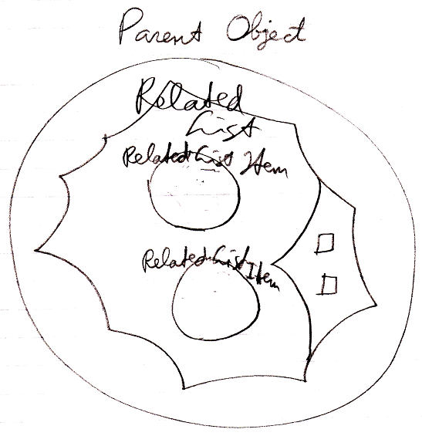

The complete system interface of the related list system object looks like this:

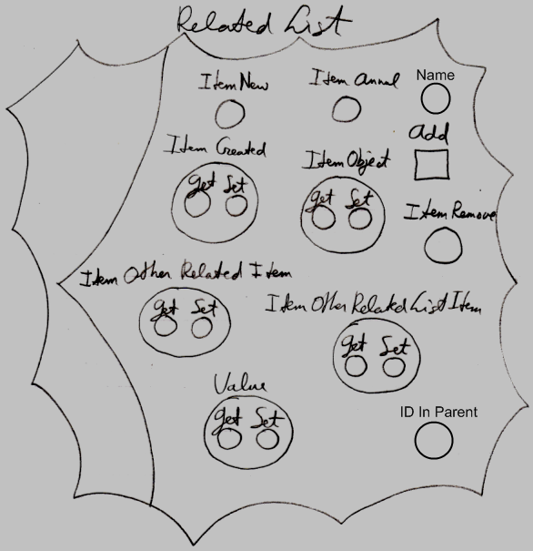

A related list has the following members:

Add
Name
ID In Parent

These members will be covered by the articles:

- Add
- Names of Related Items & Related Lists
- Related Items & Related Lists Collections

The other members of the system interface of a related list only contain references to procedure extensions for related list items. The related list item members that get extended are covered in the articles:

- New & Annul
- Object Get & Set
- Pointer To Pointer Get & Set
- Value Get & Set
- Remove

For further information about extending the system commands, see the article Extending the System Interface.

See also: System Objects, Related Lists, Add, Names of Related Items & Related Lists, Related Items & Related Lists Collections, New & Annul, Object Get & Set, Pointer To Pointer Get & Set, Value Get & Set, Remove, Extending the System Interface

Author & Copyright: Jan-Joost van Zon Date: July 18, 2008 – July 24, 2008 Location: Oosterhout, The Netherlands Status: Finished

